**Name:**

CIS313 Week 2 Worksheet

You must show your work in details when answering Q1-Q8 . You will lose 50% of the grade if you didn’t show your work.

1. What base 10 number is the same as the binary number 11011001? ___217__

1. What base 10 number is the same as the binary number 100001? __33___

1. What base 10 number is the same as the binary number 1100001111? __783___

1. What binary number is the same as the base 10 number 78? __1001110___

1. What binary number is the same as the base 10 number 974? _111100111____

1. What binary number is the same as the base 10 number 1024? __10000000000___

1. Convert the binary number 111111011011 into –
   1. hexadecimal: _FDB____
   2. decimal: __4059___

1. Convert the binary number 111110011 into:
   1. hexadecimal: __1F3___
   2. decimal:__499___

1. Use the logical operator AND on the following:

1011011011110001

1110101101001010

1111111111111011

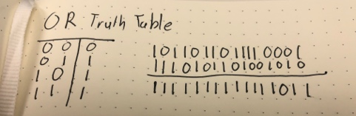

1. Use the logical operator OR on the following:

1011011011110001

1110101101001010

1111111111111011

1. Use the logical operator XOR on the following:

1011011011110001

1110101101001010

0101110110111011

1. Find at least two applications for converting numbers among binary, decimal, and hexadecimal, and list them, or the sites from which they originate.

<https://coolconversion.com/math/binary-octal-hexa-decimal/>

Unix command line utility bc. (Included some examples.)

